*(9) Considerations for candidate system.*

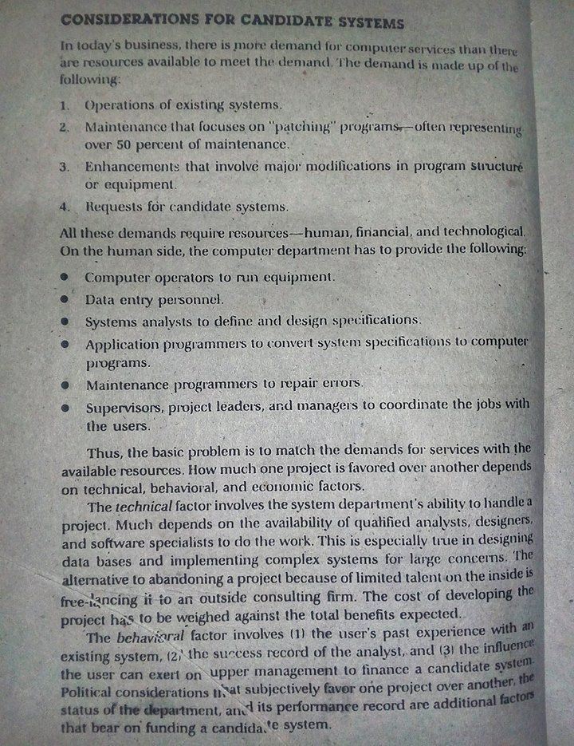

P - 50

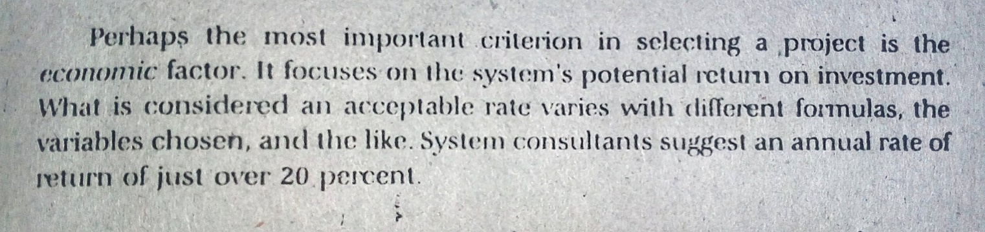

P - 51